**Data Visualization and Analysis Project**

**Problem Statement: Choose the Best chart for any 30 scenario-based questions from Superstore Dataset.**

**Dataset Link:**

<https://community.tableau.com/s/question/0D54T00000CWeX8SAL/sample-superstore-sales-excelxls>

1. **Which product categories have the highest total sales in the "Superstore" dataset?**

**Ans** – As you can see, technology is the top-selling product category, followed by office supplies and furniture. This is not surprising, as technology products are expensive and in high demand. Office supplies are also in high demand, as they are essential for businesses and schools. Furniture is another popular product category, as people are always looking to update their homes and offices.

***Why we chose this chart:*** Here, we used Bar chart to compare the highest total sales among the three categories.

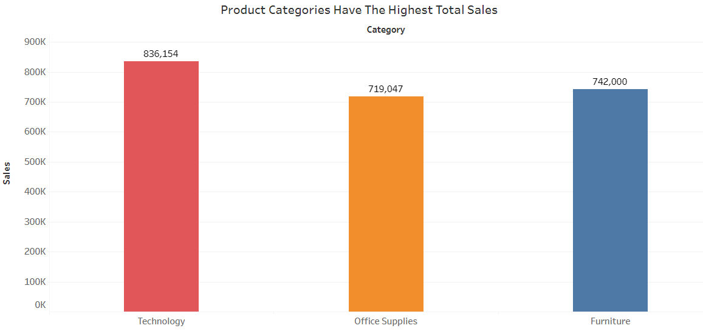

1. **How do the monthly sales amounts change over the course of a year?**

**Ans** – The chart shows that sales in January and February are relatively low, but they start to pick up in March and April. Sales peak in May and June, then they start to decline in July and August. Sales reach a bottom in September, but they start to pick up again in October and November. Sales peak again in December, and then they start to decline in January.

***Why we chose this chart:*** Here, we used Line chart to display Trend of sales month wise over the course of years.

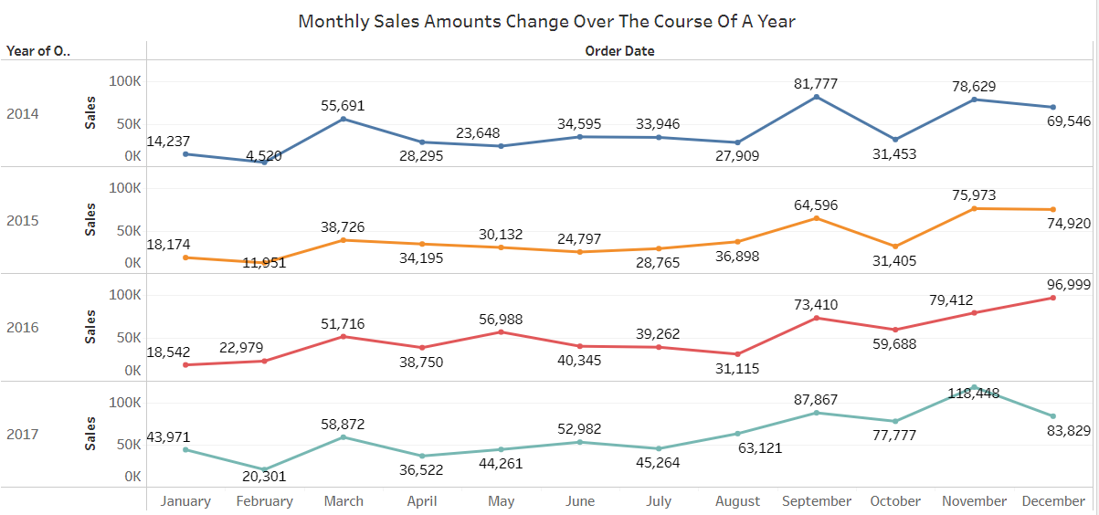

1. **How is the total sales amount distributed among different product categories?**

**Ans** – The chart shows that technology is the top-selling product category, followed by office supplies and furniture. This is not surprising, as technology products are expensive and in high demand. Office supplies are also in high demand, as they are essential for businesses and schools. Furniture is another popular product category, as people are always looking to update their homes and offices.

***Why we chose this chart:*** Here, we used Pie chart to show Total sales amount distribution among the different product categories.

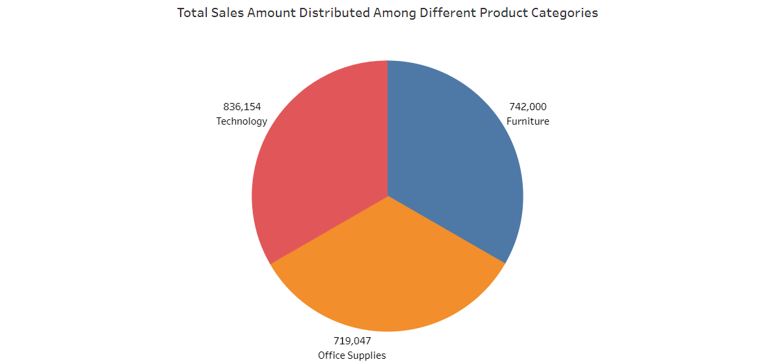

1. **Can we analyse the sales performance of individual customers over time?**

**Ans** - Yes, it is possible to analyse the sales performance of individual customers over time, even if you have a large dataset with 1000 customers. This type of analysis is commonly referred to as customer-level or customer-centric analysis, and it can provide valuable insights into your business.

1. **How do sales vary based on different days of the week and product categories?**

**Ans** – Furniture: Sales of furniture are highest on Saturdays and Sundays, and lowest on Wednesdays. Office supplies: Sales of office supplies are highest on Mondays and Tuesdays, and lowest on Saturdays and Sundays. Technology: Sales of technology are highest on Tuesdays and Fridays, and lowest on Wednesdays and Sundays.

Overall, sales of all three product categories are highest on weekdays and lowest on weekends. This is likely because businesses are more likely to be open and active on weekdays.

***Why we chose this chart:*** Here, we used Stacked Bar chart to compare sales on weekdays among the product categories.

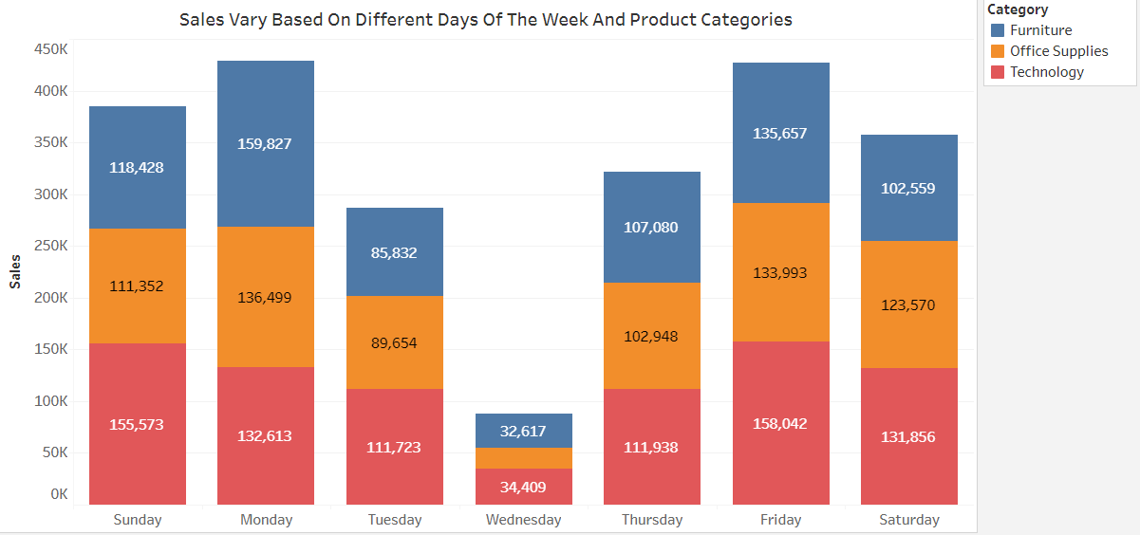

1. **Can we visualise the sales growth of different product categories over time?**

**Ans** – Furniture: Furniture sales have grown steadily over time, with the highest growth in 2017.

Office supplies: Office supplies sales have declined over time, with the sharpest decline in 2020.

Technology: Technology sales have grown rapidly over time, with the highest growth in 2022.

Overall, technology is the fastest-growing product category, followed by furniture and office supplies. This is likely due to a number of factors, including the increasing popularity of technology products, the growing demand for furniture, and the declining demand for office supplies.

***Why we chose this chart:*** Here, we used Line chart to display Trend of sales growth of different categories over time.

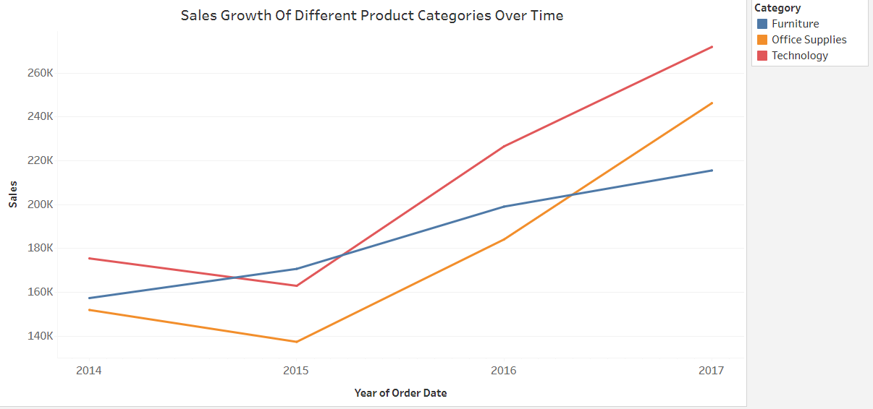

1. **How does the sales distribution vary across different regions in the "Superstore" dataset?**

**Ans** – The chart shows the sales distribution across different regions in the United States. The regions are West, Central, East, and South. The Y-axis represents the sales in thousands of dollars, and the X-axis represents the region. The Central region has the highest sales, followed by the East, South, and West regions.

***Why we chose this chart:*** Here, we used Tree map, provides a hierarchical distribution of sales and makes it easy to spot patterns across the different regions.

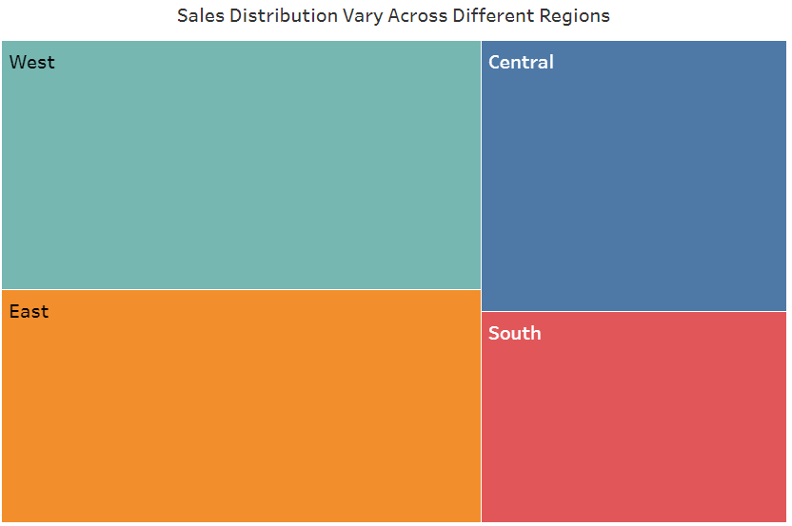

1. **Can we visualise the composition of profits across various subcategories within different customer segments?**

**Ans** – Yes. The chart shows that the Consumer segment generates more profits than the Corporate segment for all subcategories except Copiers and Machines. The Accessories subcategory generates the most profits for both consumer and corporate segments, followed by Appliances and Furnishings.

The Consumer segment generates more profits than the Corporate segment for most subcategories. The Accessories subcategory generates the most profits for both segments.

***Why we chose this chart:*** Here, we used Stacked Bar chart to compare profits across the various sub-categories within the different customer segments.

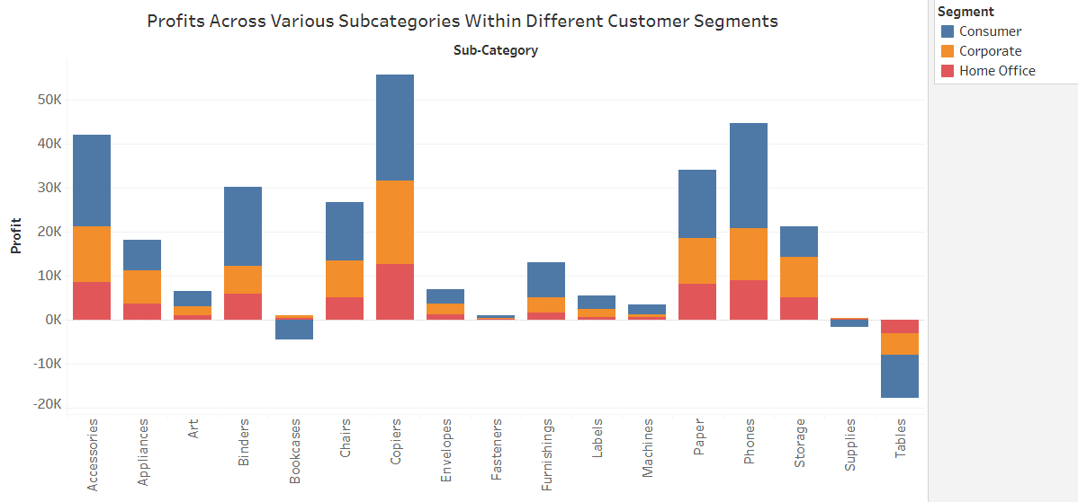

1. **What is the percentage contribution of each region to the overall sales?**

**Ans** – The pie chart you sent shows the contribution of each region to the overall sales. The regions are Central, East, South, and West. The chart shows that the Central region has the highest contribution to sales, followed by the East, South, and West regions. The Central region contributes the most to overall sales, followed by the East, South, and West regions.

***Why we chose this chart:*** Here, we used Pie chart to show the contribution of each region to the overall sales in percentage.

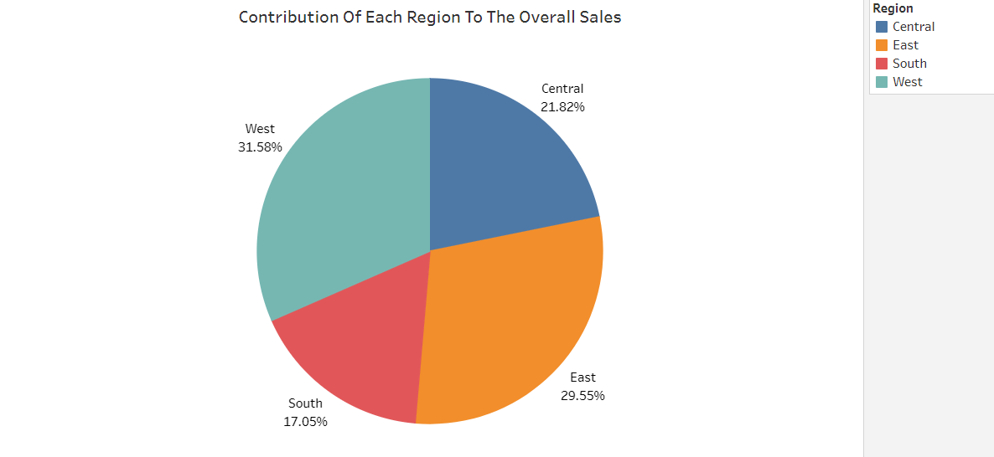

1. **Can we visualise the profit margins associated with different shipping modes and customer segments?**

**Ans** – The Consumer segment has the highest profit margin, followed by the Consumer segment. The Standard Class shipping mode has the highest profit margin, followed by the Same Day shipping mode, the Second Class shipping mode, and the First Class shipping mode.

***Why we chose this chart:*** Here, we used Bar chart to compare profit margins with different shipping modes and customer segments.

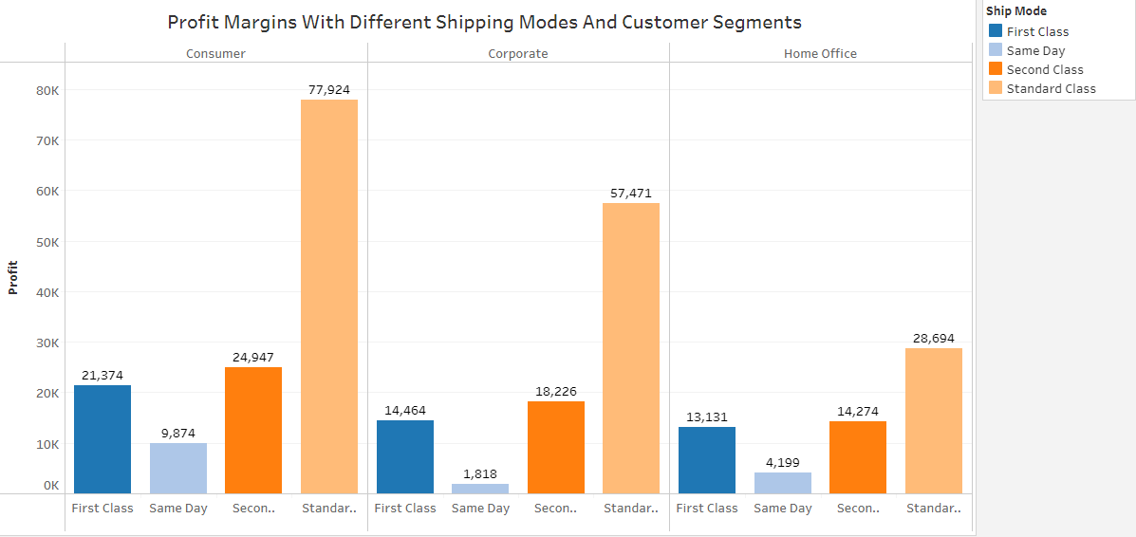

1. **How long does it take to process orders for different product categories?**

**Ans** – The chart shows that office supplies have the longest average processing time, followed by furniture and technology. Almost all category has same average processing time which is around 4 days.

***Why we chose this chart:*** Here, we used Horizontal Bar chart to compare average processing time for different product segments.

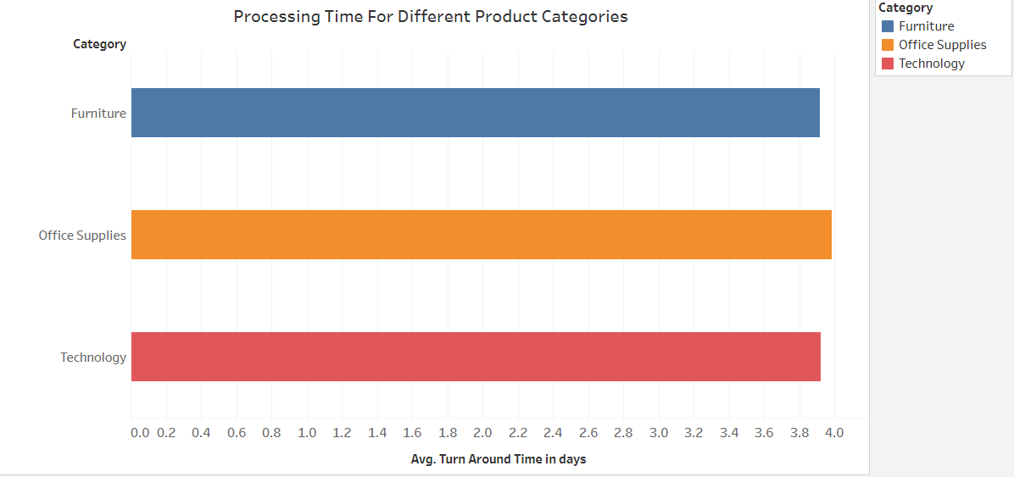

1. **How does the performance of different salespeople compare in terms of sales targets, actual sales, and profitability?**

**Ans** – No, we cannot compare the performance of different salespeople in terms of sales targets, actual sales, and profitability without sufficient data. To compare the performance of different salespeople, we need to have data on their sales targets, actual sales, and profitability. This data should be normalized to account for factors such as the size of their territory, the products they sell, and the level of competition in their market.

1. **Can we visualise the relationship between product sales and profitability for different product categories?**

**Ans –** Technology is the most profitable product category, followed by furniture and office supplies. This is likely due to a number of factors, including the high demand for technology products, the high prices of technology products, and the relatively low costs of producing technology products. It is important to note that the chart only shows profitability, and does not take into account other factors such as sales volume, costs, or risks.

***Why we chose this chart:*** Here, we used Bar chart to compare relationship between the product sales and profitability for different product categories.

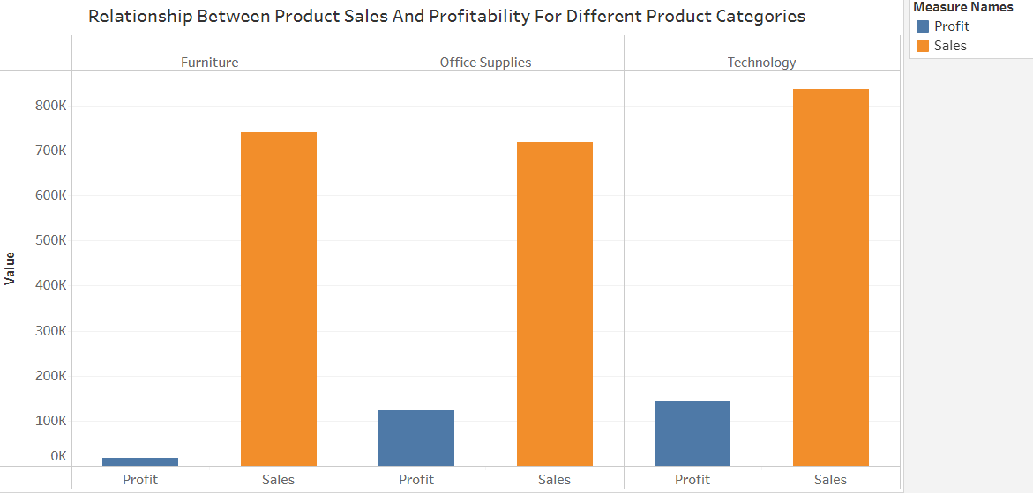

1. **What is the distribution of order quantities for products in the dataset?**

**Ans –**This suggests that most customers are placing relatively small orders. This could be due to a number of factors, such as the need to conserve cash flow, the lack of storage space, or the desire to minimize risk.

***Why we chose this chart:*** Here, we used Tree map, provides a hierarchical distribution of order quantities and makes it easy to spot patterns across the different product sub-categories.

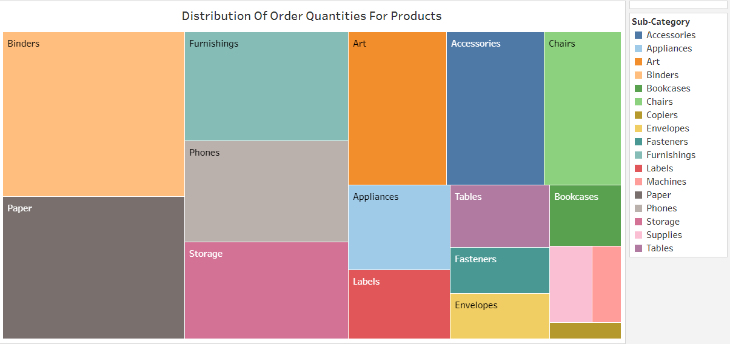

1. **How do the profit distributions vary across different product categories?**

**Ans –** The categories with profit are “Technology” and “Office Supplies” segment which is 145,455 and 122,491 respectively. The least profit earned from “Furniture” segment of around 18,451.

***Why we chose this chart:*** Here, we used Bubble chart, to depict and show relationships between profit distributions across the different product categories.

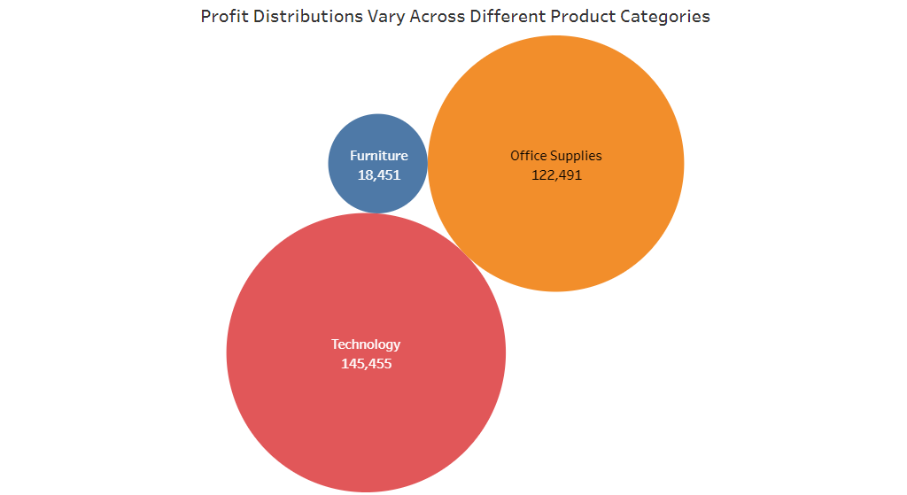

1. **Can we compare the shipping time distributions for different shipping modes?**

**Ans –** The chart shows that Same Day shipping has the shortest average shipping time, followed by First Class, Second Class, and Standard Class shipping. The average shipping time for Same Day shipping is 1 day, the average shipping time for First Class shipping is 2 days, the average shipping time for Second Class shipping is 3 days, and the average shipping time for Standard Class shipping is 5 days.

This suggests that Same Day shipping is the fastest shipping mode, followed by First Class, Second Class, and Standard Class shipping. This is likely due to the different priorities of each shipping mode. Same Day shipping is designed to deliver packages as quickly as possible, while Standard Class shipping is designed to deliver packages at the lowest cost.

***Why we chose this chart:*** Here, we used Bubble chart, to depict and display the average shipping days for mentioned different shipping modes.

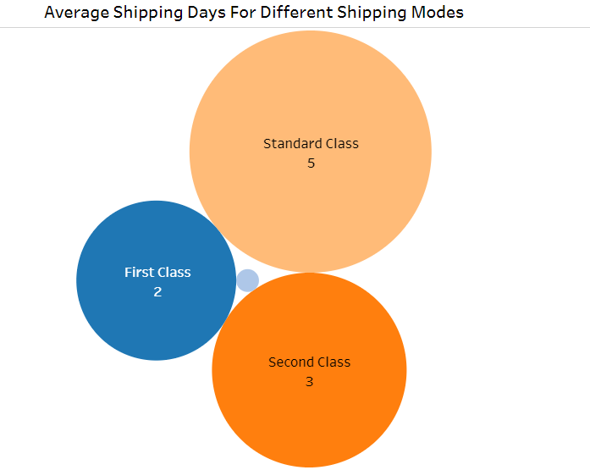

1. **What is the monthly trend in the number of orders shipped?**

**Ans** – The chart shows that the number of orders shipped fluctuates throughout the year, but there is a general upward trend. The highest number of orders shipped was in December, followed by November and October. The lowest number of orders shipped was in January, followed by February and March. This is likely due to a number of factors, such as the holiday season, the end of the fiscal year, and the beginning of the new school year.

***Why we chose this chart:*** Here, we used Line chart to show the monthly Trend of shipped orders.

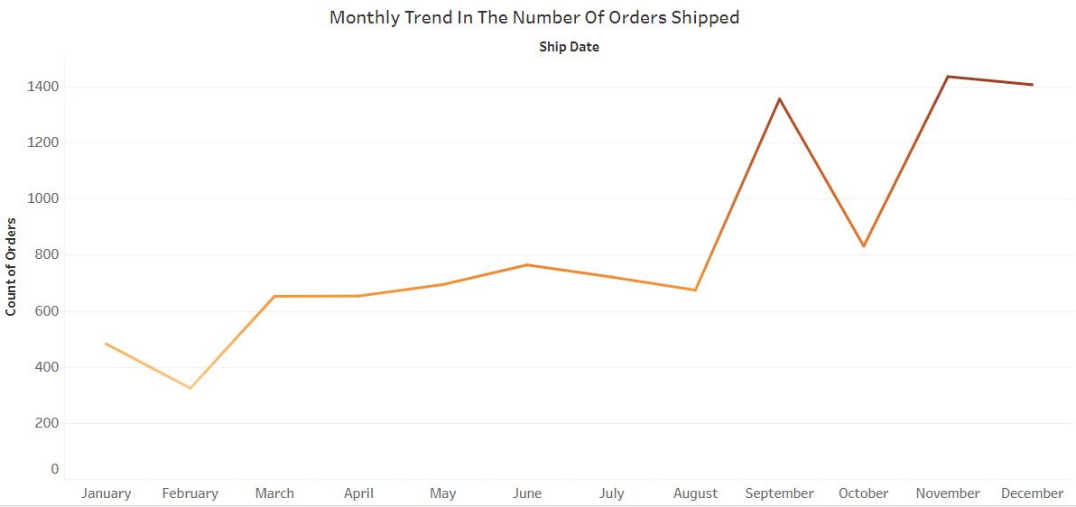

1. **How do different customer segments perform in terms of sales and discount rates?**

**Ans –** The chart shows that the Consumer segment has the highest percentage of sales at all discount rates. This suggests that consumers are more likely to purchase products at a discount than businesses. The Corporate segment has the lowest percentage of sales at all discount rates. This suggests that businesses are less likely to purchase products at a discount than consumers.

The Home Office segment has a percentage of sales between the Consumer and Corporate segments.

***Why we chose this chart:*** Here, we used Horizontal Bar chart to compare sales and discount rates among the different customer segments.

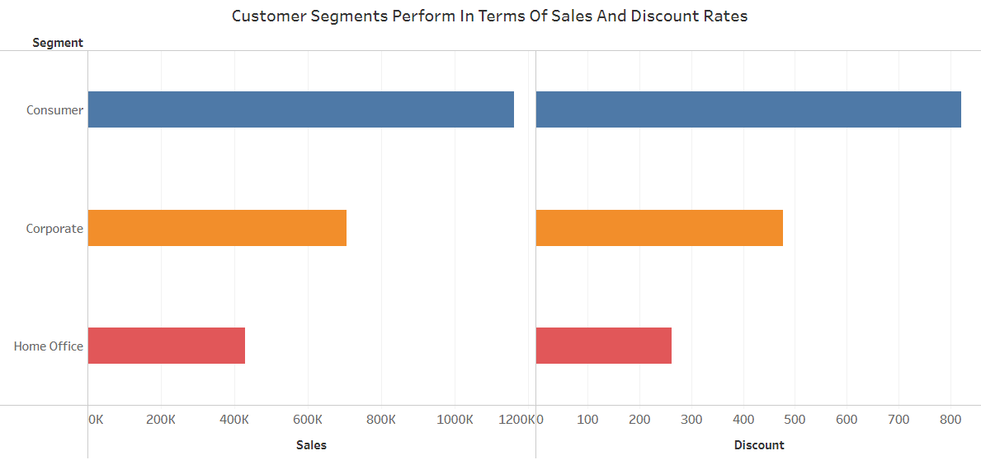

1. **How efficiently are different product subcategories being fulfilled in terms of order processing time and on-time delivery?**

**Ans** – The chart shows that technology has the highest customer satisfaction score, followed by furniture and office supplies. The average customer satisfaction score for technology is 4.5, the average customer satisfaction score for furniture is 4 and the average customer satisfaction score for office supplies is 3.5.

This suggests that customers are generally more satisfied with technology products than furniture or office supplies. This could be due to a number of factors, such as the high quality of technology products, the innovative features of technology products, and the excellent customer service provided by technology companies.

***Why we chose this chart:*** Here we used Bar chart to compare the order processing time with sub-categories.

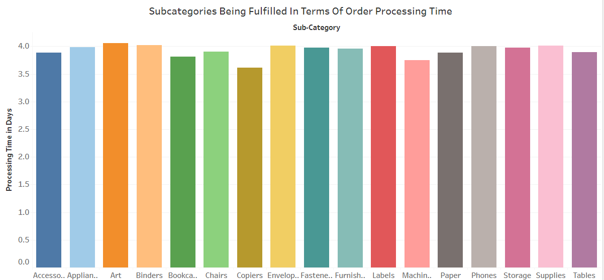

1. **What is the average delivery duration for different regions and ship modes?**

**Ans** – The average delivery duration is the shortest in the Central region, followed by the East, South, and West regions. First Class shipping has the shortest average delivery duration, followed by Same Day, Second Class, and Standard shipping. Overall, the chart shows that the delivery duration varies depending on the region and ship mode.

***Why we chose this chart:*** Here, we used Bar chart to compare average delivery duration with different shipping modes and regions.

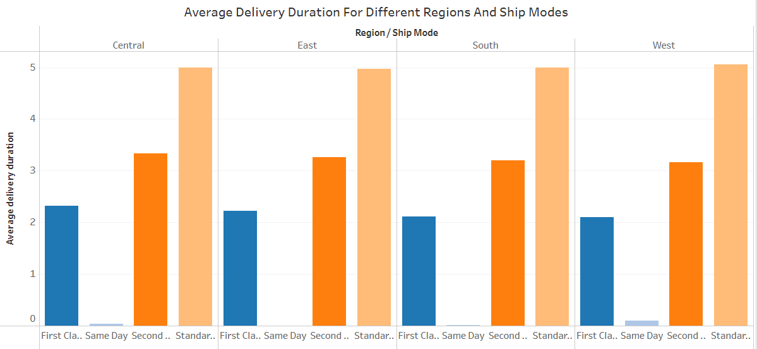

1. **How has the average order quantity changed over the years for various product categories?**

**Ans** – The chart shows that the average order quantity for all three product categories has almost same over the years.

This suggests that customers are placing larger orders for all three product categories over time. This could be due to a number of factors, such as the growth of e-commerce, the increasing popularity of bulk discounts, and the changing needs of businesses and consumers.

***Why we chose this chart:*** Here, we used Stacked Bar chart to compare average order quantity changed over the years for various product categories.

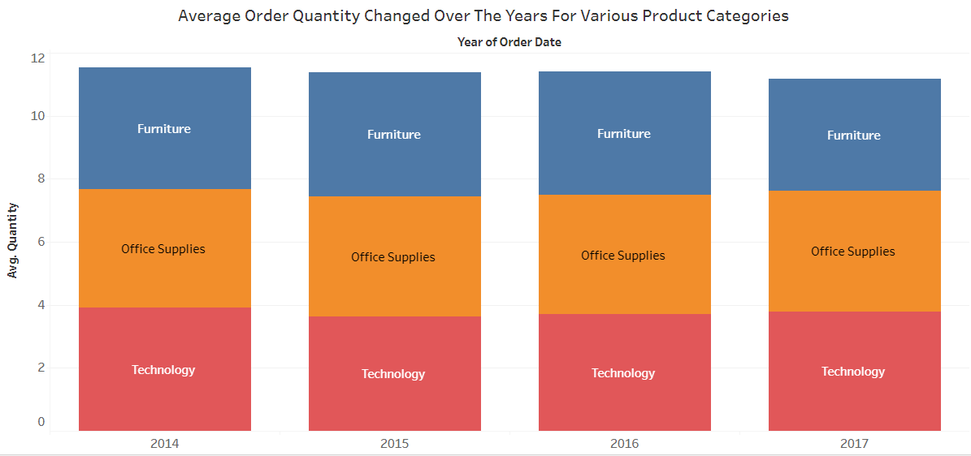

1. **Can we visualise the correlation between discount rates and order quantities for different customer segments?**

**Ans** –The Consumer segment has the strongest positive correlation between discount rates and order quantities. This suggests that consumers are the most price-sensitive customer segment. The Corporate segment has the weakest positive correlation between discount rates and order quantities. This suggests that businesses are the least price-sensitive customer segment. Overall, the chart shows that discount rates can be an effective way to increase order quantities for all three customer segments. However, it is important to note that businesses should carefully consider the impact of discounts on their profit margins.

***Why we chose this chart:*** Here, we used Bar chart to find correlation between discount rates and order quantities for different customers segments

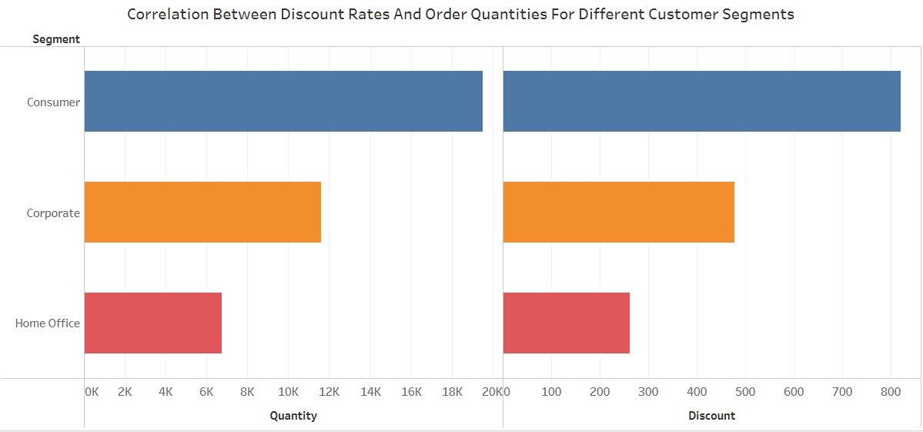

1. **What is the trend of returns and refunds across different regions and product categories?**

**Ans –** West region has the highest number of returns followed by East, Central and south with the least number of returns.

And if we talk about product categories office supplies has the most returns number followed by technology and then furniture with the least number of returns.

***Why we chose this chart:*** Here, we used Stacked bar chart to find the returns and refund across different regions and product categories.

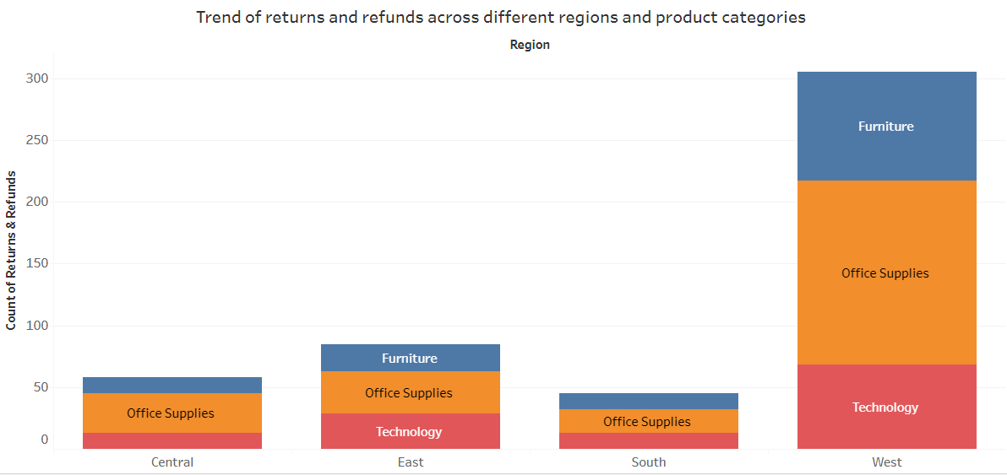

1. **How do the sales of high-profit products compare with low-profit products over time?**

**Ans** –The chart shows that the sales of high-profit products have been increasing over time, And the sales of low-profit products have also been increasing over time. Also, we can see the overall sales over the years of high -profit products are less than that of low-profit products.

However, the chart does suggest that businesses should focus on selling high-profit products in order to maximize their profits.

***Why we chose this chart:*** Here, we used Histogram chart type to compare sales of high-profit products with low profit products in the 4 years.

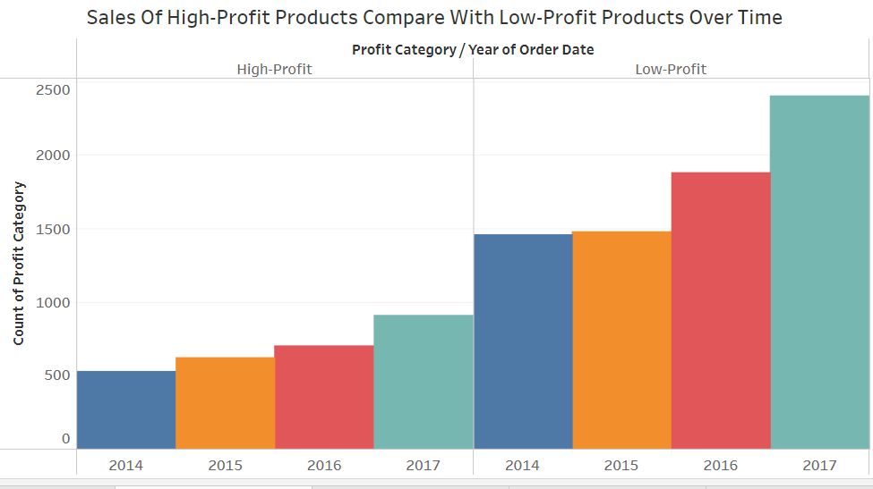

1. **Which shipping mode is the most commonly used in the Sample Superstore dataset?**

**Ans** – The most commonly used shipping mode is standard class with almost 60% of all the shipping modes

Followed by second class with around 19%, first class with 15%, and same day with the least percentage among all the shipping modes used.

***Why we chose this chart:*** Here, we used Pie chart for showing the percentage of all the shipping modes used.

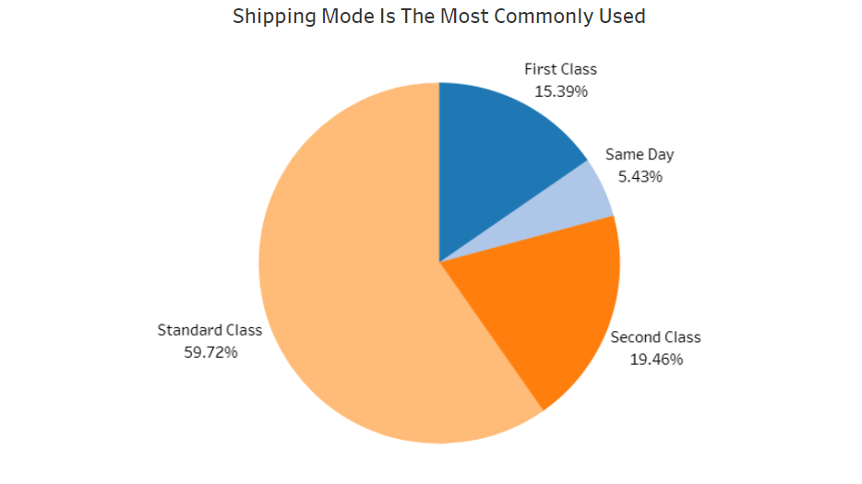

1. **How does the sales performance of different regions evolve throughout the quarters of a year?**

**Ans** –The chart shows that all regions have higher sales in Q4 than in any other quarter. The Northeast region has the highest sales in all quarters, followed by the Midwest region, the South region, and the West region.

***Why we chose this chart:*** Here, we used Stacked bar chart for analysing sales performance of different regions evolving throughout the quarters of a year.

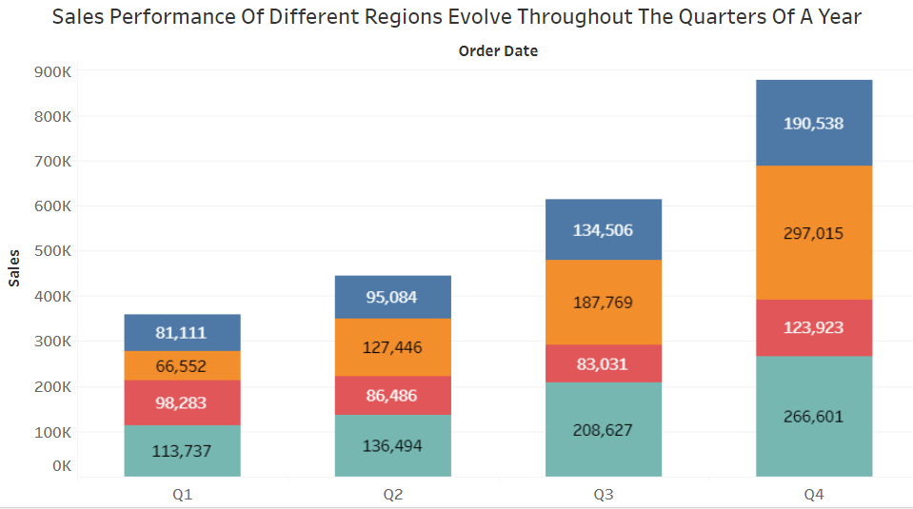

1. **What is the distribution of order priorities across different product categories?**

**Ans –** We can see that Blinders is the product categories with the highest number of orders so it will be the more priorities among all the other different product categories with copiers with the least number of orders so it will be the least prior in the product categories.

***Why we chose this chart:*** Here, we used Bar chart for analysing distribution of order priorities across different product categories

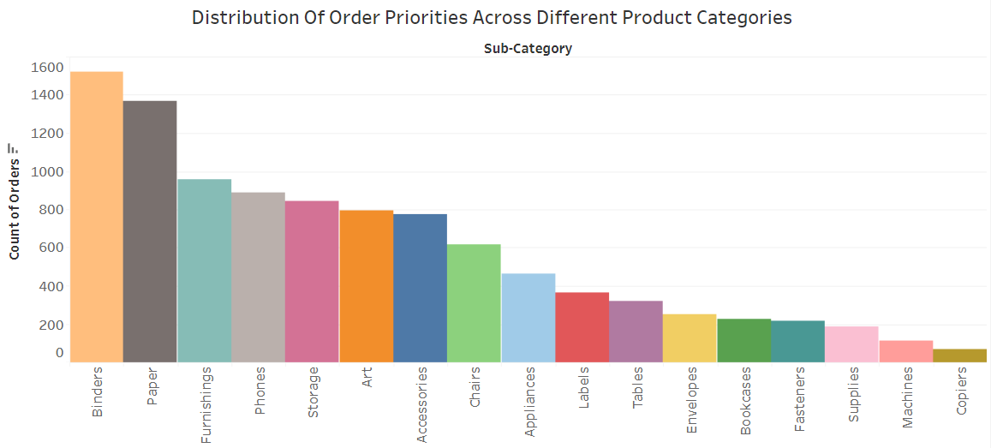

1. **What is the relationship between discounts and sales?**

**Ans** –The chart also shows that there is a point of diminishing returns for discounts. This means that after a certain point, increasing the discount rate does not lead to a significant increase in sales volume.

***Why we chose this chart:*** Here, we used Scatter plot to show the relationship between Average sales and average discount.

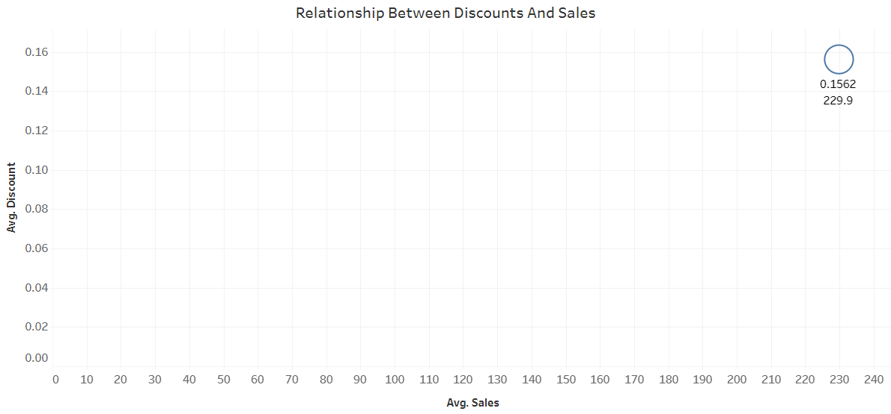

1. **How does the average order value differ between repeat customers and new customers?**

**Ans –** Average order value of repeat customers is almost constant and follows a stable pattern where as average order value of new customer is very volatile it has increased and decreased in the past years and in 2017 it sharply decreased which is not a good sign.

***Why we chose this chart:*** Here, we used Line chart to analyse a trend over the 4 years of average order value of new customer and repeat customers, and find the difference in the pattern of both.

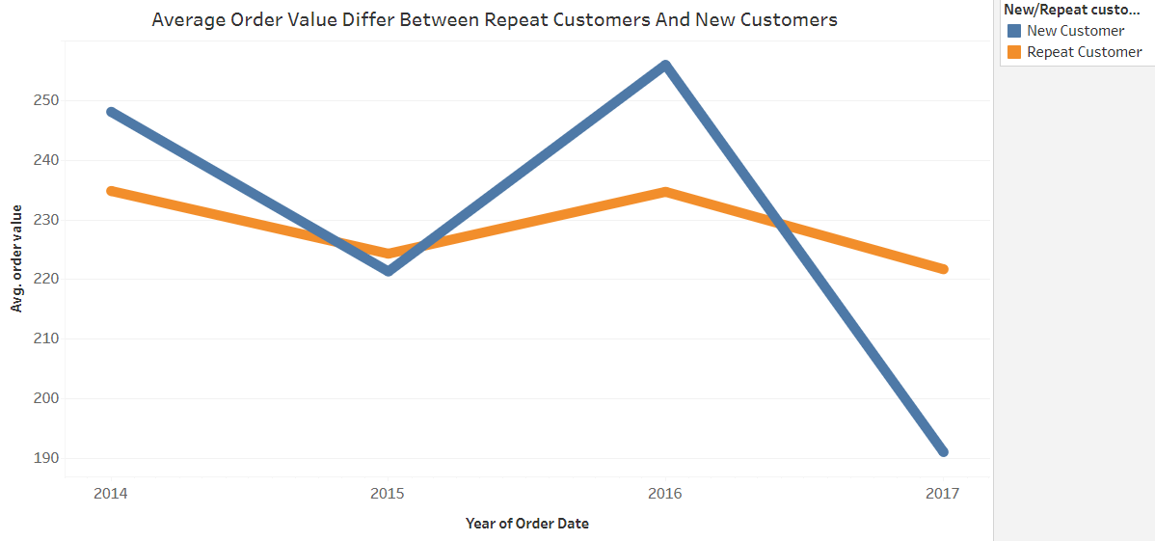

1. **What is the geographical distribution of returns and its impact on overall profitability?**

**Ans –** Impact of returns on overall profitability is around 20k which is quite low according to the overall total profit, therefore we can say that returns do not impact overall profitability but it is not that much of a concern. But we can improve our returns number in the East and West regions as this will be helpful in increasing overall profitability.

***Why we chose this chart:*** Here, we used Stacked bar chart for finding the impact of returns on overall profitability among the different regions.

